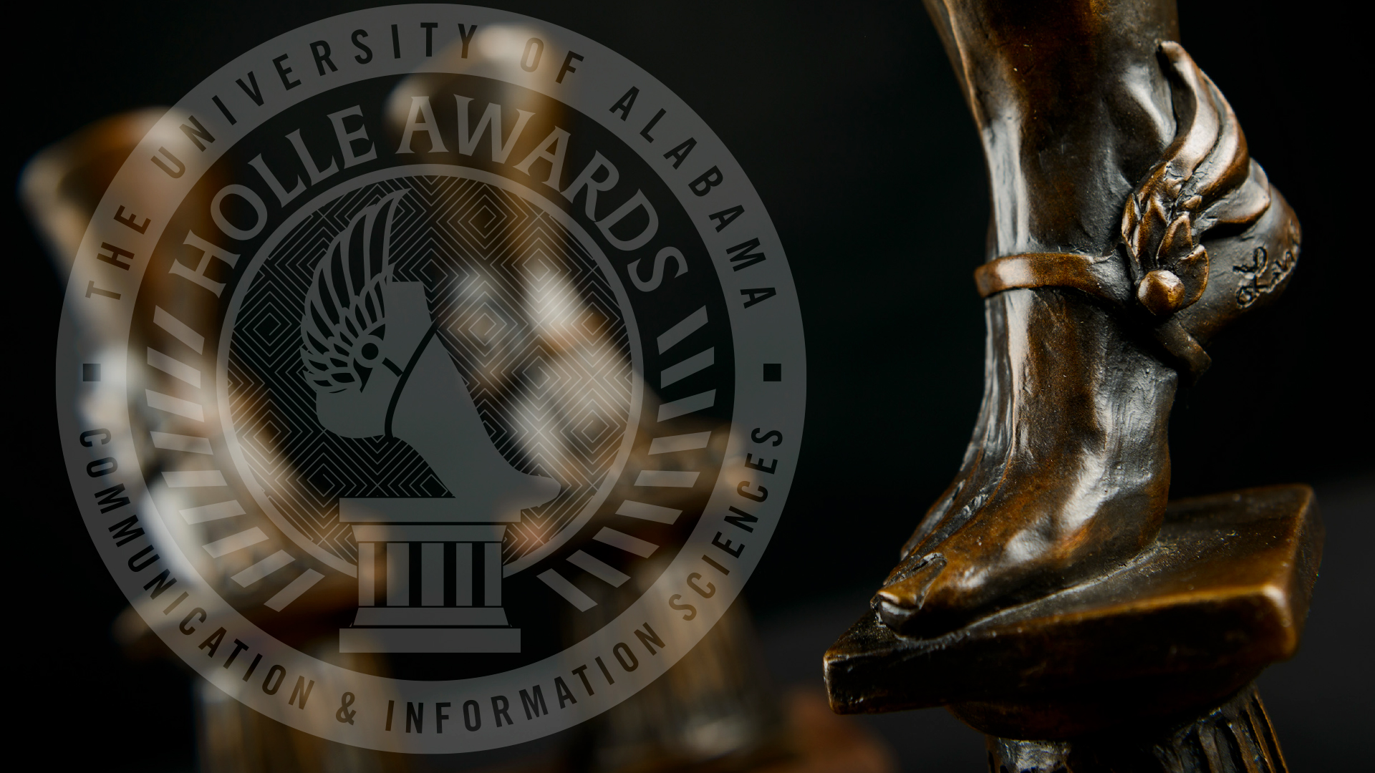
September 2023

The Dr. Frank M. Thompson Jr. Crimson Classic Tournament &
UA Alumni Swing Tournament

Dear Colleagues,

We cordially invite you to attend the Crimson Classic Swing Tournament held in Tuscaloosa, Alabama by The University of Alabama, named for Dr. Frank M. Thompson, former Director of our program. Dr. Thompson remains one of the great torchbearers of forensics. His name rings synonymous with both excellence and joy in what we do. We, at UA, owe him our deepest gratitude and respect.

This year, we are excited to continue sharing an exciting award with the forensics community:

The Holle Award for Excellence in Forensic Competition

The Holle Awards for Excellence in Creativity and Communication at The University of Alabama celebrate and reward student achievement in the areas of book arts, filmmaking, forensics, media writing, public speaking, screenwriting, and sports media. These annual awards include a $10,000 prize for the winner of each category.

Individual Events Competitors at the Crimson Classic & UA Alumni Swing Tournament eligible for individual sweepstakes and who compete in at least 4 events with one event in each genre (Limited Preparation, Public Address, and Oral Interpretation) will have the opportunity to win The Holle Award for Excellence in Forensic Competition, which includes a $10,000 prize.

Additionally, we will offer IPDA debate both halves of the swing tournament.

We hope that you will attend our in-person swing tournaments October 7th and 8th.

In the following pages, you will find tournament information for all forensic events. We greatly appreciate each of you. If we can be of further assistance, please contact us. See you soon!

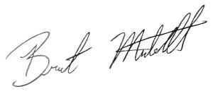
Sincerely,

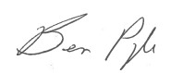
Ben Pyle Brent Mitchell
Director Assistant Director
Alabama Forensic Council Alabama Forensic Council

The Dr. Frank M. Thompson Jr.
Crimson Classic & UA Alumni Swing Tournament
October 7th – 8th, 2023

CRIMSON CLASSIC/UA ALUMNI TOURNAMENTS
There will be two preliminary rounds with finals. Events that have over 50 entries will go to semis. A school can have unlimited entries in each event. The student must not have used the material before September 1, 2023. There are no restrictions on the number of entries per student. However, if schools cannot fulfill judging obligations, we reserve the right to slate rounds to use all judges. Depending on event size, students from the same school may compete against each other. To assure smooth, on-time competition, cross-entries are not allowed between debate and I.E.

FEES: $10.00 per covered I.E. slot and $35 per IPDA slot – An additional $15 for judge fees per uncovered I.E. slot and $75 per uncovered IPDA slot. One judge covers 6 I.E. slots. Teams who have faced significant budgetary reductions or are student-run may reach out to the tournament director to seek a waiver for fees.

JUDGES: All judges should be actively coaching faculty, graduate students, or persons with forensic experience. All judges will be responsible for judging one round past the elimination of their students -- this means all judges are obligated to judge events in ALL flights that go straight to finals. Due to judge constraints, it is possible we will need IE judges to judge past their obligations.

PLEASE BRING JUDGES!

REGISTRATION: All entries need to be entered on speechwire.com. All students and judges will need activated Speechwire accounts before tournament registration.

MAKE ALL CHECKS FOR THE DR. FRANK THOMPSON JR. CRIMSON CLASSIC & UA ALUMNI SWING TOURNAMENT TO:
The University of Alabama

Please send your checks to:
Carol Duncan
Communication Studies Dept.
Reese Phifer Hall Room 203
Box #870172
Tuscaloosa, AL 35487

DEADLINES: All entries must be received by 12:00 noon CST Tuesday, October 3rd. NO ADDS PAST 12 NOON OCT 4th. Drops can be made until Wednesday October 4th at noon. After this time, we will impose a late-drop fee of an additional $25.00 per I.E. slot, and $50.00 per judge dropped. Entry drops made the day of registration will be $50.00 and judge drops will be $100.00. ALL drops will be added to the original entry fee.

The Dr. Frank M. Thompson Jr.
Crimson Classic & UA Alumni Swing Tournament
October 7th – 8th, 2023

I.E. Competition will be offered in all 11 AFA – NST events following the AFA – NST rules.

AWARDS: Awards will be given to all finalists and semi-finalists, the top novice in each event, and all Quadrathon finalists. To qualify for the Quadrathon Award, a student must be entered in four events. These events must be a combination of two of the following: oral interpretation, prepared speaking, and limited preparation. The Quad Awards are based on performance in final rounds. The top three schools will receive a sweepstakes award (based on final round performances), and awards will be given to the Top Junior College.

HOLLE AWARD FOR EXCELLENCE IN FORENSIC COMPETITION: The $10,000 prize is awarded annually to the winner of the individual sweepstakes award at the Invitational Tournament hosted at The University of Alabama. This award recognizes excellence across the spectrum of individual event forensic competition as it awards the competitor who performs best in each genre: Literary Interpretation, Limited Preparation, and Public Address. In addition to excellent presentation skills, this award demonstrates a nuanced mastery of critical thinking, persuasion, quick interpretation and dissemination of information, and artistic performance. To qualify for the Holle Award, a student must be entered in four events for both halves of the Dr. Frank M. Thompson Jr. Crimson Classic & UA Alumni Swing Tournament. These events must include an event in EACH of the three genres: oral interpretation, prepared speaking, and limited preparation.

DIRECTIONS
Tuscaloosa is located 55 miles southwest of Birmingham, AL. The majority of participants will travel I-59/20 – they become the same interstate from Birmingham on into Mississippi. A few might travel highway 82 East. On I-59/20 you will take the McFarland Blvd. exit and turn left onto McFarland Blvd. – if you are coming in from Mississippi you will take a right on to McFarland Blvd. You will go through two red lights.

To Campus you will need to take McFarland Blvd (West 82) to the University Blvd. exit. University Blvd. will take you directly to the middle of campus.

The Dr. Frank M. Thompson Jr.
Crimson Classic & UA Alumni Swing Tournament
October 7th – 8th, 2023

CRIMSON CLASSIC TOURNAMENT – UA HOST
Saturday, October 15
7:00 – 7:30 a.m. Registration – FOR BOTH IE TOURNAMENTS & IPDA
Reese Phifer Hall Rotunda
7:30 a.m. Extemp Draw IPDA Round 1
8:00 – 9:30 a.m. Round I Flight A
9:00 a.m. IPDA Round 2
9:30 – 11:00 a.m. Round I Flight B
11:00 a.m. – 12:15 p.m. LUNCH/District 6 Coaches Meeting – Location Reese Phifer Hall
12:15 – 1:45 p.m. Round II Flight B IPDA Round 3
1:45 p.m. Extemp Draw IPDA Round 4
2:15 – 3:45p.m. Round II Flight A
3:15 p.m. IPDA Quarters
3:45 p.m. Out-Round Set 1
4:30 p.m. IPDA Sems
5:00 p.m. Extemp Draw Finals
5:30 p.m. Out-Round Set 2
6:00 p.m. IPDA Finals
6:45 p.m. Out-Round Set 3
ASAP Awards – Reese Phifer Hall Room 216 (tentative)
(Note: If our judging situation allows, we will consolidate and remove the 3rd finals set. It is also possible this schedule will adjust if semis are needed)

UA ALUMNI TOURNAMENT – ALUMNI HOST
Sunday, October 16
7:00 a.m. LATE REGISTRATION FOR THOSE ATTENDING ONLY THE ALUMNI HALF
7:30 a.m. Extemp Draw IPDA Round 1
8:00 – 9:30 a.m. Round I Flight A
9:00 a.m. IPDA Round 2
9:30 – 11:00 a.m. Round I Flight B
11:00 a.m. – 12:00 p.m. LUNCH
12:15 – 1:45 p.m. Round II Flight B IPDA Round 3
1:45 p.m. Extemp Draw IPDA Round 4
2:15 – 3:45p.m. Round II Flight A
3:15 p.m. IPDA Quarters
3:45 p.m. Out-Round Set 1
4:30 p.m. IPDA Sems
5:00 p.m. Extemp Draw Finals
5:30 p.m. Out-Round Set 2
6:00 p.m. IPDA Finals
6:45 p.m. Out-Round Set 3
ASAP Awards – Reese Phifer Hall Room 216
(Note: If our judging situation allows, we will consolidate and remove the 3rd finals set)

Flight Patterns:
A: EXT DUO ADS PERS PROSE POI
B: CA DRAMA POE IMP INFO

The Dr. Frank M. Thompson Jr.
Crimson Classic & UA Alumni Swing Tournament
October 7th – 8th, 2023

I.E. TOURNAMENT EVENT DESCRIPTIONS
Impromptu Speaking: An impromptu speech, substantive in nature, with topic selections varied by round and by section. Topics will be derived from quotations or questions. Speakers will have a total of 7 minutes for both preparation and speaking. Timing commences with the acceptance of the topics sheet. Limited notes are permitted.

Informative Speaking: An original, factual speech by the student on a realist subject to fulfill the general aim to inform the audience. Audio-visual aids may or may not be used to supplement and reinforce the message. Multiple sources should be used and cited in the development of the speech. Minimal notes are permitted. Maximum time is 10 minutes.

Prose Interpretation: An original or selections of prose material of literary merit, which may be drawn from more than one source. Focus of this event is on the development of the narrative/story. Play cuttings and poetry are prohibited. Use of manuscript is required. Maximum time is 10 minutes including introduction.

Duo Interpretation: A cutting from one or more texts of literary merit, humorous or serious, involving the portrayal of two or more characters presented by two individuals. The material may be drawn from any genre of literature. This is not an acting event; thus, no costumes, props, lighting, etc., are to be used. Presentation is from the manuscript and the focus should be off-stage and not to each other. Maximum time limit is 10 minutes including introduction.

Extemporaneous Speaking: Contestants will be given three topics in the general area of current event, choose one, and have 30 minutes to prepare a speech that is the original work of the student. Maximum time limit for the speech is 7 minutes. Limited notes are permitted. Student will speak in listed order. Postings of topics will be staggered.

Persuasive Speaking: An original speech by the student designed to inspire, reinforce, or change the beliefs, attitudes, values or actions of the audience. Audio-visual aids may or may not be used to supplement and reinforce the message. Multiple sources should be used and cited in the development of the speech. Minimal notes are permitted. Maximum time limit is 10 minutes.

Program Oral Interpretation: A program of thematically-linked selections of literary merit, chosen from two or three recognized genres of competitive interpretation (prose/poetry/drama). A primary focus of this event should be on the development of the theme through the use of narrative/story, language, and/or characterization. A substantial portion of the total time must be devoted to each of the genres used in the program. Different genre means the material must appear in separate pieces of literature (e.g., A poem included in a short story that appears only in that short story does not constitute a poetry genre.) Only one selection may be original. Use of manuscript is required. Maximum time limit is 10 minutes including introduction.

After Dinner Speaking: An original, humorous speech by the student, designed to exhibit sound speech composition, thematic, coherence, direct communicative public speaking skills, and good taste. The speech should not resemble a night club act, an impersonation, or comic dialogue. Audio-visual aids

The Dr. Frank M. Thompson Jr.
Crimson Classic & UA Alumni Swing Tournament
October 7th – 8th, 2023

may or may not be used to supplement and reinforced the message. Minimal notes are permitted. Maximum time limit is 10 minutes.

Communication Analysis: An original speech by the student designed to offer an explanation and/or evaluation of a communication event such as a speech, speaker, movement, poem, poster, film, campaign, etc., through the use of rhetorical principles. Audio-visual aids may or may not be used to supplement and reinforce the message. Manuscripts are permitted. Maximum time limit is 10 minutes.

Drama Interpretation: A cutting that represents one or more characters from a play or plays of literary merit. The focus of this event is on the development of characterization. This material may be drawn from stage, screen, or radio. Use of manuscript is required. Maximum time limit is 10 minutes including introduction.

Poetry Interpretation: A selection or selections of poetry of literary merit, which may be drawn from more than one source. A primary focus of this event should be on the development of language. Play cuttings and prose works are prohibited. Use of manuscript is required. Maximum time limit is 10 minutes including introduction.

The Dr. Frank M. Thompson Jr.
Crimson Classic & UA Alumni Swing Tournament
October 7th – 8th, 2023

IPDA DEBATE TOURNAMENT EVENT DESCRIPTIONS

International Public Debate (IPDA): IPDA utilizes a one-on-one debate format in which one debater takes the side of the affirmative where they have the burden of advocating and proving the resolution, following IPDA rules (http://www.ipdadebate.info/index.html). The opposing debater takes the side of the negative where they refute the affirmative’s case. For each round, the two debaters are given five possible resolutions. The negative begins the topic selection by striking one resolution, then the affirmative strikes one resolution. The negative strikes again. Thus, the affirmative has two resolutions from which to choose. The affirmative then strikes one of the remaining resolutions, selecting the other as the topic for the round. After the topic has been selected, both debaters have 30 minutes to prepare.

IPDA COMPETITION RULES
To ensure fairness, our tournament will follow IPDA rules found within the IPDA Constitution and Bylaws updated on October 2018. To view the constitution, please visit: http://www.ipdadebate.info/constitution--bylaws.html.
The 15-minute forfeit rule will apply if a debater fails to appear at their designated competition room.
According to the IPDA Constitution, “IPDA” or the “International Public Debate Association” is an audience-friendly debate format with great emphasis on persuasion, rhetorical speaking abilities, and inclusivity of interested individuals who are encouraged to debate “regardless of educational background, prior experience, or any other demographics.” The philosophic tenets of the IPDA Constitution are sevenfold, which are inclusivity, lay judging, limited preparation, extemporaneous delivery, rhetorical delivery, and ethos.
It is important to note that IPDA Debate differs from other collegiate debate formats since it encourages lay judging – judges with limited debate experience and training to ensure fairness within debate rounds. Therefore, handouts of the IPDA debate format will be distributed at check-in to all lay judges who request a copy of the IPDA Debate rules.

The Dr. Frank M. Thompson Jr.
Crimson Classic & UA Alumni Swing Tournament
October 7th – 8th, 2023

The IPDA Debate format are as follows:
- Topics will be announced in-round with 5 topics (2 value, 2 policy, 1 metaphor) provided for strikes. Negative strikes first, and then turns are taken until one topic remains to be debated.

- Debaters are allowed to consult other persons during prep time, including coaches.
Per IPDA rules, they will be allowed paper and/or electronic research material, which
may be quoted or paraphrased from notes during the round, but not read directly, as
extemporaneous delivery is required.

- Time limits:
Affirmative Constructive 5 minutes
Cross Examination 2 minutes
Negative Constructive 6 minutes
Cross Examination 2 minutes
First Affirmative Rebuttal 3 minutes
First Negative Rebuttal 5 minutes
Second Affirmative Rebuttal 3 minutes
30 Minutes Prep. Time from Topic Strike
1-40 Speaker Point System

ADDITIONAL NOTES ON THE IPDA DEBATE FORMAT
- Competitors will receive their topics at their designated competition room 30 MINUTES BEFORE THE ACTUAL ROUND BEGINS. (Example: if the first round starts at 9:00AM, then competitors MUST be at their designated rooms no later than 7:30AM).
- Judges are expected to keep time during IPDA & NPDA preparation time. IPDA competitors will have exactly 30 minutes of preparation time following the first negative strike.

